Catford CC Hill Climb: A Historic Challenge
The Catford Cycling Club's first hill climb took place on August 20th, 1887, with 24 riders attempting to conquer Westerham Hill in Kent. Back then, this hill was considered nearly impossible to ascend on a bicycle, especially with solid tires and unmade roads, making it particularly treacherous for riders on ‘Penny Farthings.’ The winner of that inaugural race was Mr. S.F. Edge.
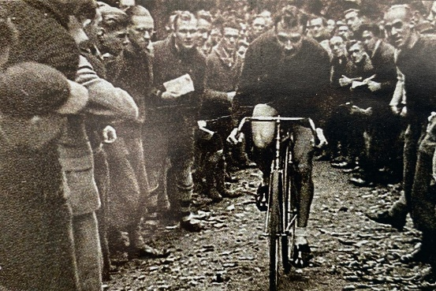
Fast forward 137 years, and on Sunday, October 11th, 2024, the Catford Cycling Club hosted its 128th hill climb on Yorks Hill, Sevenoaks, Kent. This race is believed to be the ‘Oldest Continuing Bike Race of its kind’. Unlike the early days, the event is now open to men and women of all ages. This year even saw a 10-year-old boy Ryan Fletcher of 4T+ Cyclopark club participate as we now have a temporary road closure for the event, possibly the youngest rider to ever attempt the climb.

Despite concerns that the unusual weather patterns might deter riders, especially given the challenge of scaling one of Kent’s steepest hills, participation remained strong. The weather held steady, with cold temperatures in single digits, but the hill was dry. Although times were slightly slower compared to last year, the riders still produced impressive performances on the 2 km long course with gradients between 4 and 5 degrees.
Congratulations to Ewan Tuohy winning the 128th Catford CC Hill Climb this morning in 1:55.8, having got closer and closer over the past eleven years. Harry MacFarlane was second with 1:58.2 and Ben Neal third with 2:09.5, Fastest woman was Junior rider Rianna Mahoney with 3:15.9, closely followed in second by Tina Lohr 3:16.7 and Kate Tidmarsh third in 3:28.9. Male Veterans1st Dan Younger 2:14.1 2nd Martin Kober 2:21.6 3r Ross Matheson 2:25.1 Women Veterans 1st Tina Lohr 3:16.7, 2nd Michelle Lewis 3:36.6 , 3rd Suzanna Kinsella 4:21.9, Male Junior 1st Charles Langford 2:15.6, Female Junior Rianna Mahoney 3:15.9, Fastest Team 4T+ Cyclopark Matthew Fletcher, Oliver Gunn, & Ross Matheson, combined time 7:05.2
Men
1st Ewan Tuohy - Arctic Aircon RT - 01:55.8
2nd Harry Macfarlane - TAAP Kalas - 01:58.2
3rd Ben Neal -Southboro & Dist Whlrs - 02:09.5

Women
1st Rianna Mahoney - 4T+ Cyclopark 03:15.9
2nd Tina Lohr - Horsham Cycling 03:16.7
3rd Kate Tidmarsh - Elevate RT 03:28.9
Men Vets
1st Dan Younger - Peckham CC 02:14.1
2nd Martin Kober - Abellio SFA Racing Team 02:21.6
3rd Ross Matheson -4T+ Cyclopark 02:25.1
Women Vets
1st Tina Lohr - Horsham Cycling 03:16.7
2nd Michelle Lewis - Peckham CC 03:36.6
3rd Suzzanna Kinsella -Tunbridge Wells Triathlon 04:21.9
1st Junior/Juvenile male
Charles Langford - Southboro & Dist Whlrs 02:15.6
1st Junior/Juvenile Female
Rianna Mahoney - 4T+ Cyclopark 03:15.9
Winning Team (Fastest from 3 riders of same club)
4T+ Cyclopark Matthew Fletcher, Oliver Gunn & Ross Matheson 07:05.2

